Maxwell Maia

St David’s Marist Inanda 2020

PAT Phase 4

Fire reviews

Table of Contents

Externally sourced code 3

Explanation of critical algorithms 4

Advanced techniques 6

Test plan and results 7

# Externally sourced code

1. Database class. (DB)
2. addSpaces method in review array. Slightly tweaked.

For login:

1. ReadToLogin() in SQLSTatements class
2. UserArray constructor
3. testCredentials() in UserArray class

All of the above was supplied by my teacher.

1. Thread.sleep() used to delay loading screen

Available from: <https://stackoverflow.com/questions/24104313/how-do-i-make-a-delay-in-java>

# Explanation of critical algorithms

Retrieving the array of games from the database and using it to find a game id based on the user’s inputs

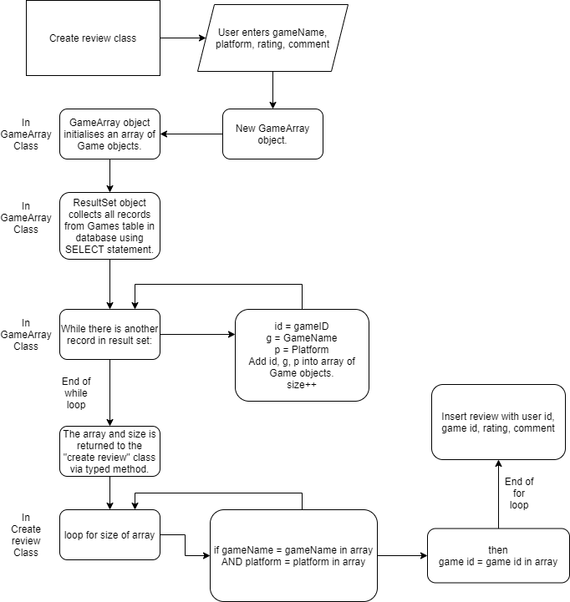The “create a review” screen needs to obtain the game id of the game the user is reviewing because the code that adds the review to the database needs the game id. To find the game id the program needs the full array of games. Therefore, this whole algorithm is critical.

Retrieving the distinct game names from the database

This is necessary to populate “Game” combo boxes. The game names are duplicated in the database because there can be multiple games with the same platform. The point of this algorithm is to populate the Game combo box without having repeating game names. This combo box is critical to the functioning of the program because the “main (filter panel)”, “create a review” and “admin tools” screens need a combo box of game names for the user to pick from.

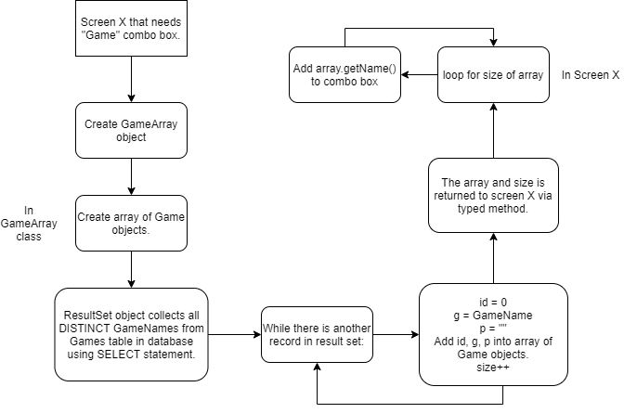

# Advanced techniques

I made a loading screen with a simple animation to make the program a little more fun. When the program is run, a loading screen is generated with the words “Fire reviews” and a picture of a dim flame. After a delay the flame “ignites” by changing to the normal flame logo.

The pictures are icons on labels. One label is initially set visible and the other set invisible. After a delay they swap visibilities.

This is the code to delay the thread. I consider this to be an advanced technique.

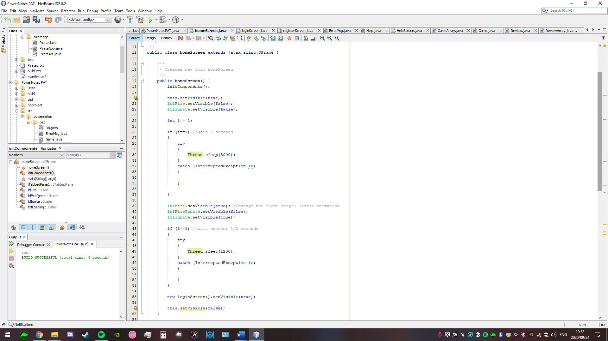

After that little animation is played another delay is used before disposing of the loading screen and opening the login screen.

# Test plan and results

**Tests**

Login

|  |  |  |  |  |
| --- | --- | --- | --- | --- |
| **Test #** | **Input** | **Normal** | **Extreme** | **Erroneous** |
| 1.1. | Username | Maxwell | This is my super long username to break the program | INSERT INTO GAMES “*(“ 100/0 |
| 1.2. | Password | maxfire123 | I need a very secure password so it has to be reaaaaaaally long. | INSERT INTO GAMES “*(“ 100/0 |

Register

|  |  |  |  |  |
| --- | --- | --- | --- | --- |
| **Test #** | **Input** | **Normal** | **Extreme** | **Erroneous** |
| 2.1. | Username | Maxwell | Super long username to break program | INSERT INTO GAMES “*(“ 100/0 |
| 2.2. | Password | maxfire123 | I need a very secure password so it has to be reaaaaaaally long | INSERT INTO GAMES “*(“ 100/0 |

Create a review

|  |  |  |  |  |
| --- | --- | --- | --- | --- |
| **Test #** | **Input** | **Normal** | **Extreme** | **Erroneous** |
| 3.1. | Game | Counter-Strike: Global Offensive | Counter-Strike: Global Offensive | (Not selected) |
| 3.2. | Platform | PC | PS4 | PS4 |
| 3.3. | Stars | 5 | 1 | 1 |
| 3.4. | Comment | Awesome game! I recommend it. | [A really long string] | JOptionPane.showMessag  eDialog(null, “I’m in the mainframe”) |

Add a game

|  |  |  |  |  |
| --- | --- | --- | --- | --- |
| **Test #** | **Input** | **Normal** | **Extreme** | **Erroneous** |
| 4.1. | Game | Counter-Strike: Global Offensive | [Nothing entered] | JOptionPane.showMessag  eDialog(null, “I’m in the mainframe”) + 100/0 |
| 4.2. | Platform | PC | PS4 | PS4 |

Filter panel

|  |  |  |  |  |
| --- | --- | --- | --- | --- |
| **Test #** | **Input** | **Normal** | **Extreme** | **Erroneous** |
| 5.1. | Game | Counter-Strike: Global Offensive | Counter-Strike: Global Offensive | Counter-Strike: Global Offensive |
| 5.2. | Platform | PC | Mobile | PS4 |
| 5.3. | Username | Maxwell | [a lot of characters] | “+100/0+INSERT ÒwÓ//* |

Admin tools consists only of a combo box. Invalid inputs are impossible

**Results**

Login

|  |  |  |  |  |
| --- | --- | --- | --- | --- |
| **Test #** | **Input** | **Normal** | **Extreme** | **Erroneous** |
| 1.1. | Username | Success | Success | Success |
| 1.2. | Password | Success | Success | Success |

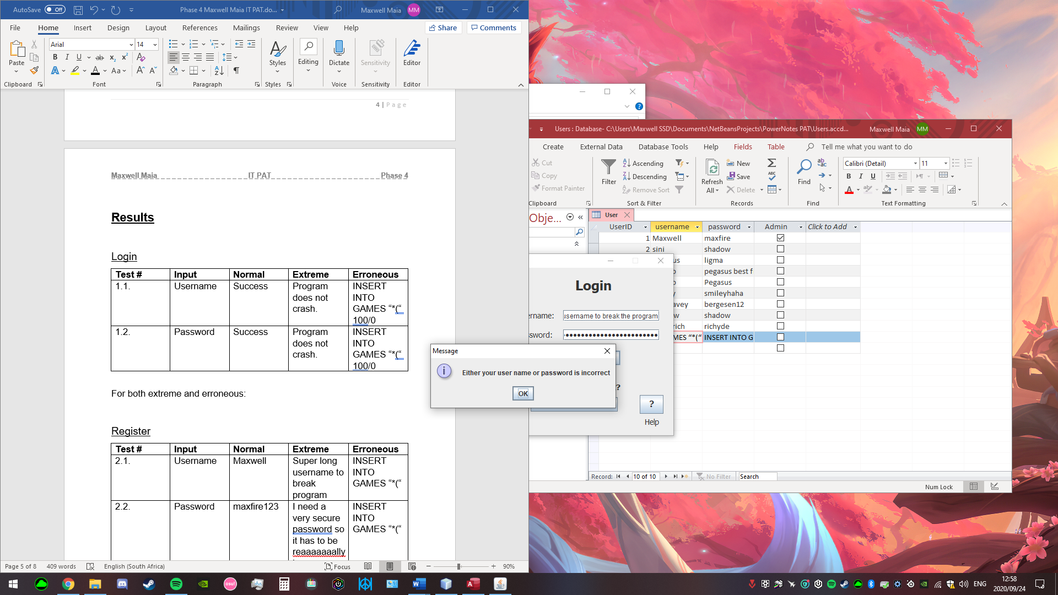

For both extreme and erroneous:  
This is what should happen.

Register

|  |  |  |  |  |
| --- | --- | --- | --- | --- |
| **Test #** | **Input** | **Normal** | **Extreme** | **Erroneous** |
| 2.1. | Username | Success | Success | Success |
| 2.2. | Password | Success | Validation success. See Fig below. | Success |

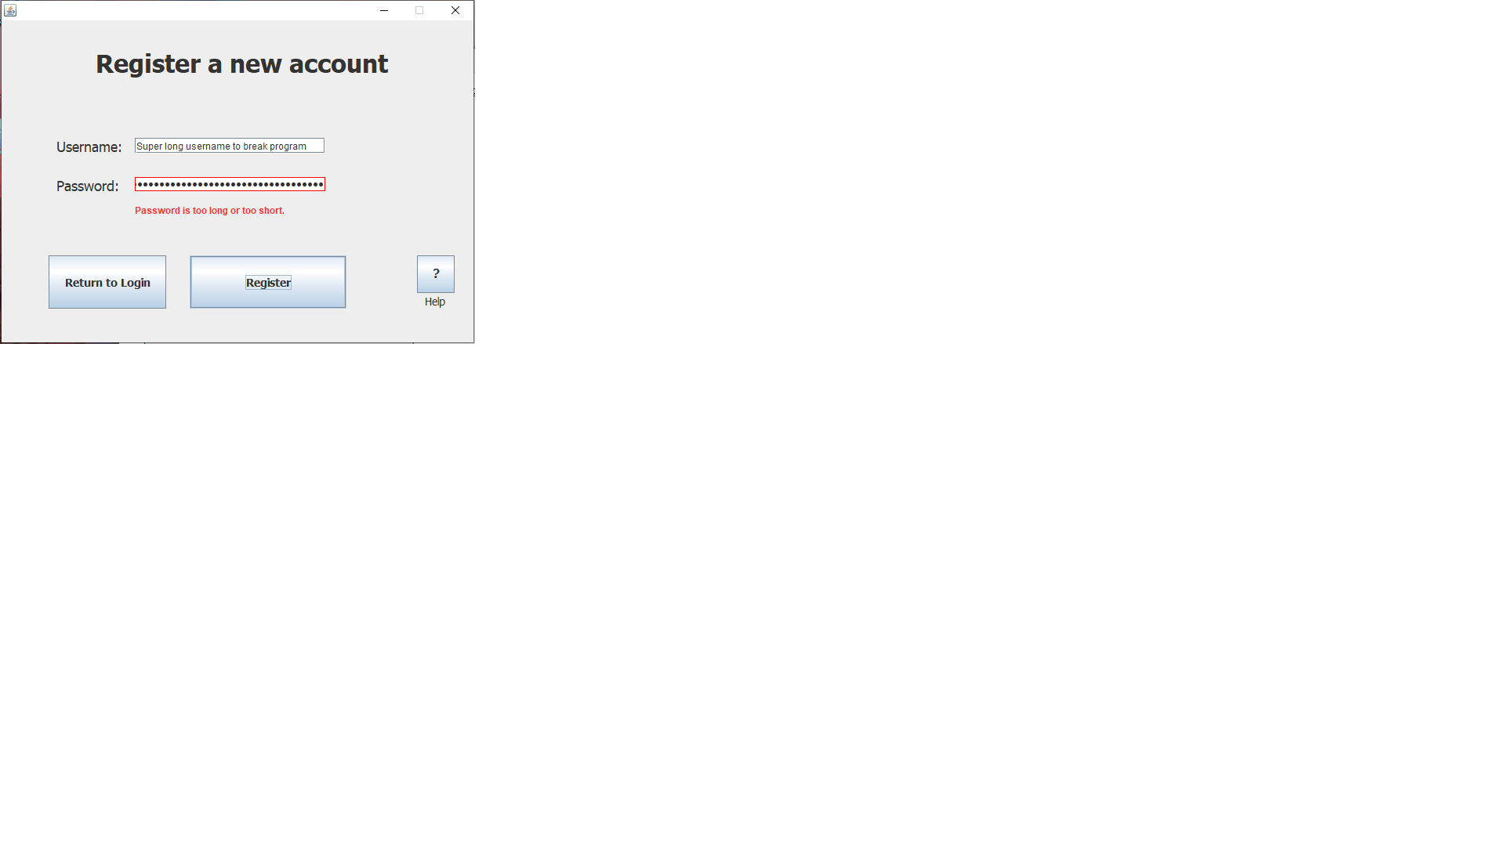

Create a review

|  |  |  |  |  |
| --- | --- | --- | --- | --- |
| **Test #** | **Input** | **Normal** | **Extreme** | **Erroneous** |
| 3.1. | Game | Success | See Fig 1. | See Fig. 2. |
| 3.2. | Platform | Success | See Fig 1. | Success |
| 3.3. | Stars | Success | Success | Success |
| 3.4. | Comment | Success | See Fig. 3 | No JOptionPane message appeared. Comment was successfully added. |

Fig 1.

The program successfully detected the invalid combination. The program did not crash.

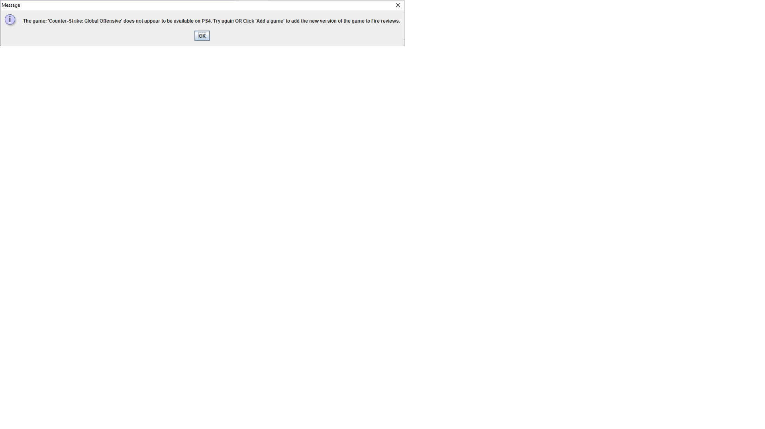

Fig 2.

The program successfully detected the invalid input. The program did not crash.

Fig 3.

The whole comment was successfully added to database and it does not crash the program when viewing the reviews. It is just very long.

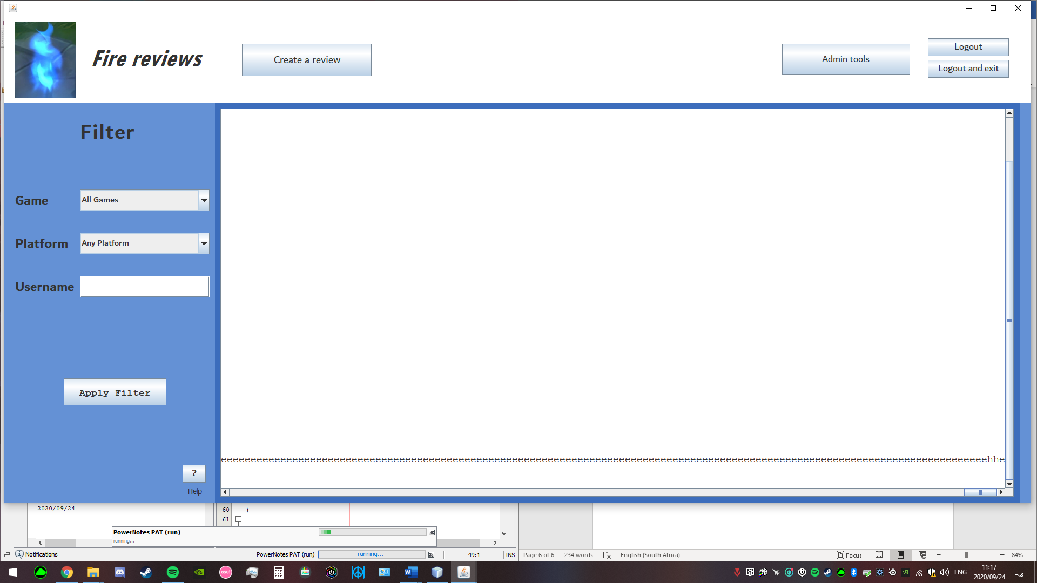

Add a game

|  |  |  |  |  |
| --- | --- | --- | --- | --- |
| **Test #** | **Input** | **Normal** | **Extreme** | **Erroneous** |
| 4.1. | Game | Success | Program successfully added an empty string to the database. | SQL Error. Program did not crash. |
| 4.2. | Platform | Success | Success | Success |

3.1. Erroneous SQL error. The program reported error and did not crash.

net.ucanaccess.jdbc.UcanaccessSQLException: UCAExc:::4.0.4 data exception: string data, right truncation; table: GAMES column: GAMENAME

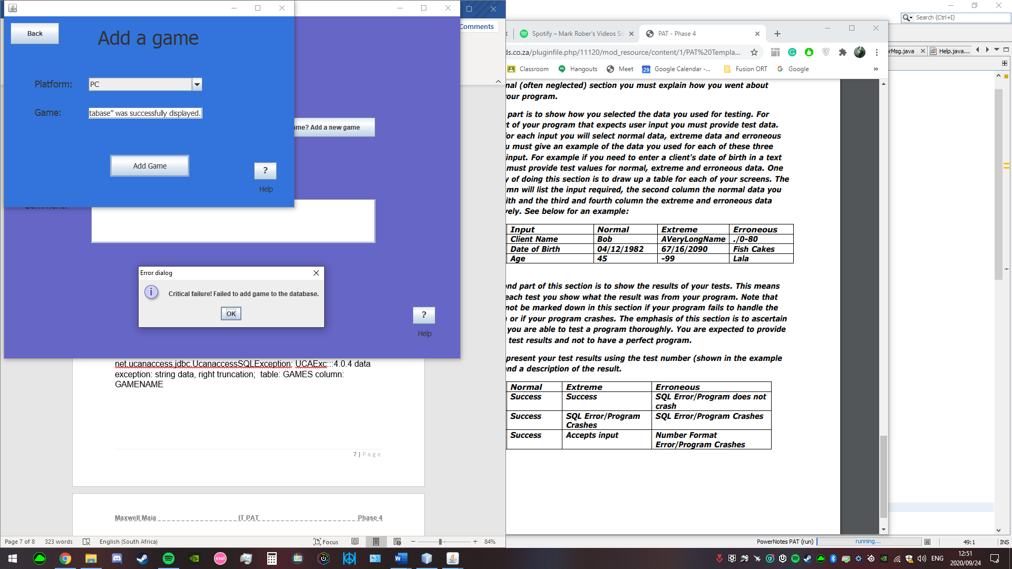

Filter panel

|  |  |  |  |  |
| --- | --- | --- | --- | --- |
| **Test #** | **Input** | **Normal** | **Extreme** | **Erroneous** |
| 5.1. | Game | Success | Success | Success |
| 5.2. | Platform | Success | Success | Success |
| 5.3. | Username | Success | Success | Success |

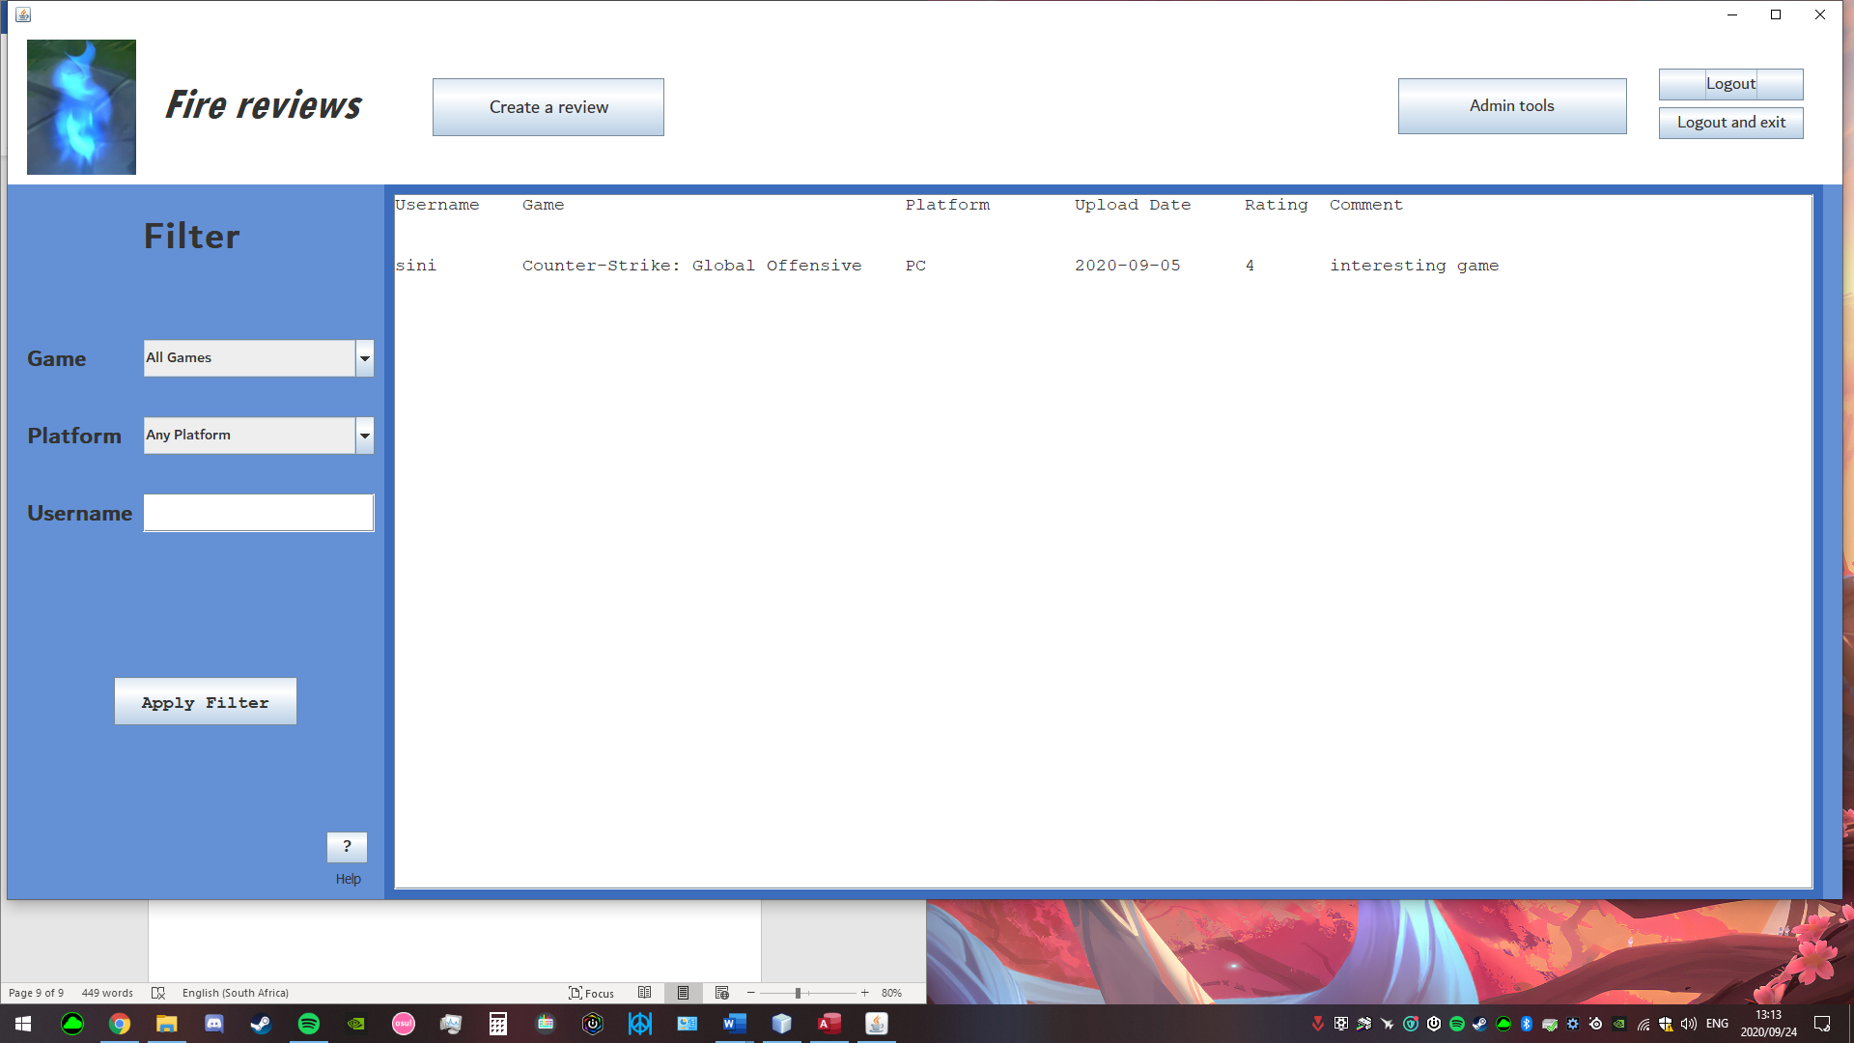Normal

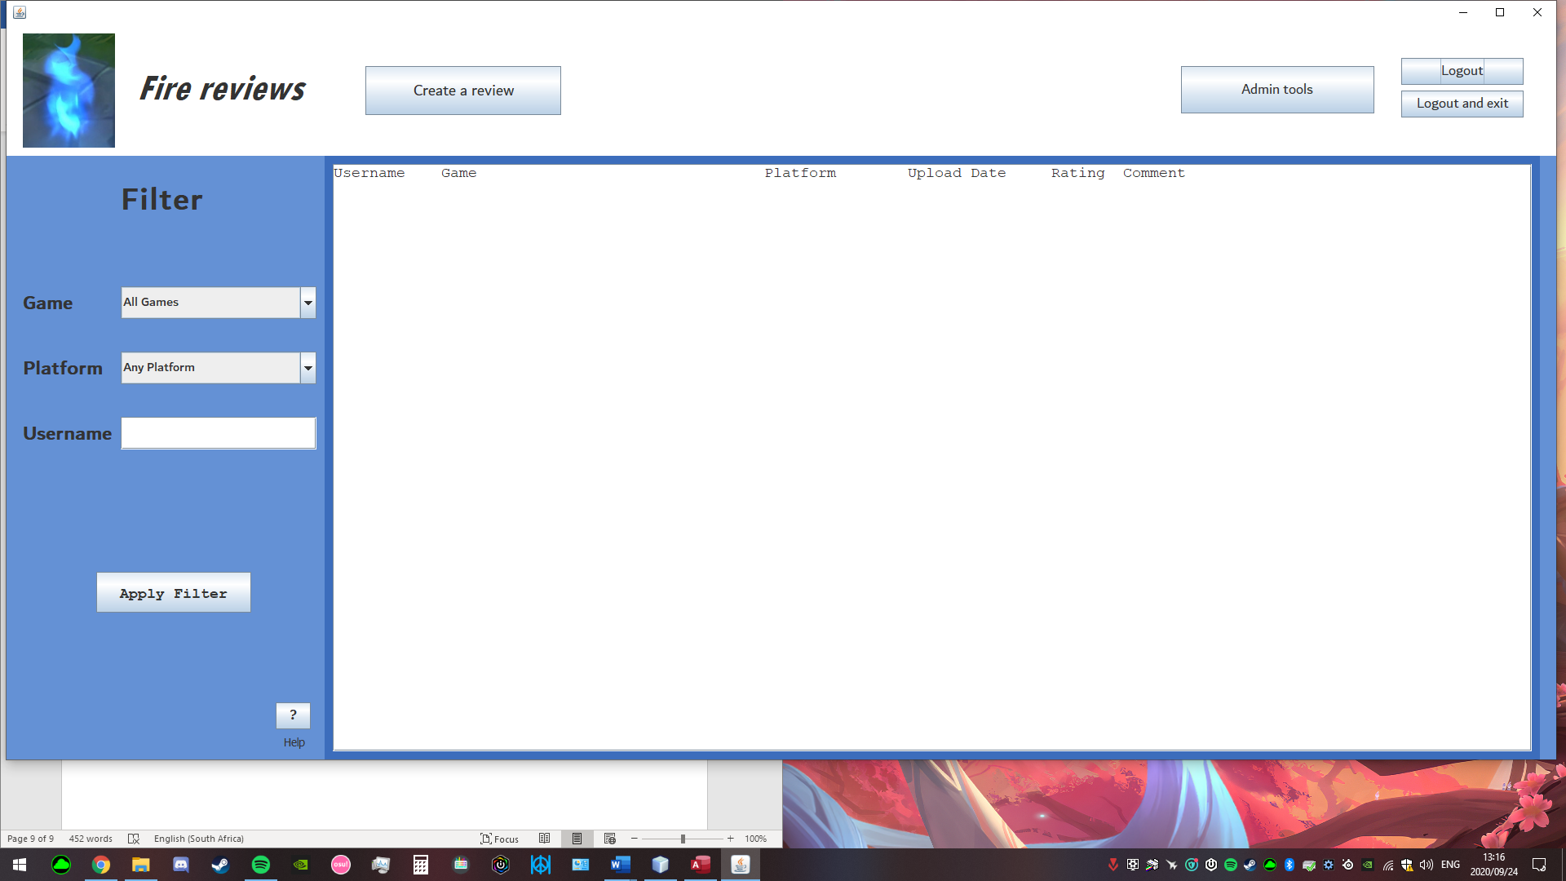Extreme (inputs are successful, but no reviews with those filters)

Erroneous (inputs are successful, but no reviews with those filters)